SHIVGADHI ENGLISH SCHOOL
Shivraj-1, Kapilvastu
1st Terminal Examination 2081
Class: Nursery F.M.
Subject: Step to Hand Writing
Name: ________________________________________________ Roll.No. _______________
- Trace the standing lines.


- Trace the steeping lines.

- Trace the left standing lines.
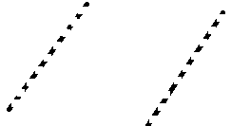

- Trace the right standing lines.

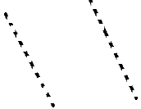

Listening
Pick up the pencil.
Show me your two fingers.
Please open the door.
THE END

